

Business Requirement Definition:

**Security Transport Application**

FOSKOR

Date: 12th October 2020

Release Status Version: Draft v1.0

# Document Control

Authors: Yolisa Nogantshi; Mpho Cele; Nomsa Sibeko

Document Reference: ~~Foskor RD.030 Inv v1.0~~

Change Record

| **Date** | **Author** | **Version** | **Change Reference** |
| --- | --- | --- | --- |
| 13 Oct 2020 | Yolisa Nogantshi | 1.0 | Initial Document |
|  |  |  |  |
|  |  |  |  |
|  |  |  |  |
|  |  |  |  |

Approvers

| **Name** | **Position** | **Signature** | **Date** |
| --- | --- | --- | --- |
| Musa Xulu | Foskor Process Owner |  |  |
| Arleen Calitz | Zirconia Process Owner |  |  |
| Johan Fraser | Foskor Business Analyst |  |  |
| Sue Brown | Foskor Business Analyst |  |  |
| Nomsa Sibeko | Foskor Business Analyst |  |  |
| Theuns Koekemoer | Foskor Project Sponsor |  |  |
| Ian James | EOH Oracle Services Project Manager |  |  |
| Jane Morison | EOH Oracle Distribution Lead |  |  |
|  |  |  |  |
|  |  |  |  |
|  |  |  |  |
|  |  |  |  |

Contents

Document Control 2

INTRODUCTION 4

Overview 4

Responsibilities 4

High Level “As Is” Business Processes 5

Transport Requesting, Data Capturing and Reporting 5

Gaps 8

Recommendations 8

High Level “To Be” Business Processes 8

# INTRODUCTION

This document provides a formal statement of the business process requirements for the Security Transport Application and forms part of the Definition phase of the project.

The document details the “As Is”, High level “To Be processes”, requirements and identified gaps.

# Overview

The Definition phase activity consists of obtaining the system functionality requirements from the users of the current application.

# Responsibilities

Foskor Process Owner :

Foskor Process Owner :

Foskor Process Operators :

Foskor Process Operators :

# High Level “As Is” Business Processes

The travel request process is manual with certain steps being processed in Microsoft Access (2010) and Microsoft Excel in order to facilitate invoicing.

1. A Foskor Supervisor manually fills in the first part of the “Request for Transport” form and informs Security Controller of the transport request
2. The Security Controller fills in the “Security Control Room use” part of the form and gives it to one of the two drivers on shift to complete
3. The Driver completes the “Security Driver” part of the form as well as the register, including the initial kilometer reading of the vehicle
4. The Driver transports the passenger(s) to or from the specified destination and returns to Foskor
5. The Driver completes details about trip and returns the form to the Data Capturer
6. The Data Capturer captures the data into the form on Access, as far as possible. Some details cannot be captured accurately due to limitations on the current application.
7. The KSS Supervisor reviews the information in Access table and copies data to Excel for editing
8. The KSS Supervisor sends a report for invoicing to KSS and Foskor Finance

The diagram below is to illustrate how the process currently flows:

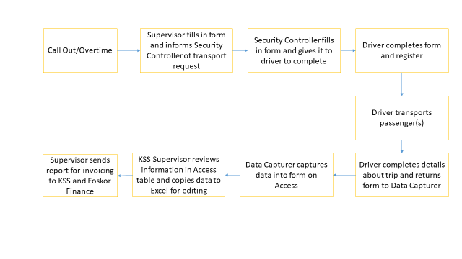

Figure 1: High Level "As Is" Process Flow Diagram

### Gaps

### Recommendations

# 

# High Level “To Be” Business Processes

The diagram below is to illustrate how the process should flow.

|  |  |
| --- | --- |
| ***Requirements*** |  |
| Process Owner/s: Musa Xulu; Arleen Calitz | Module: Order Processing |
| Responsible Consultant: Jane Morison | Category: JDE E9.1 Sales Order Management  JDE E9.1 Fulfilment Management |
| Business Rules: Standard Foskor Policies | Assumptions: Item Master and Branch Plants will be clearly and accurately defined. Transactions from Production and Warehouse will be timeously and accurately processed. |